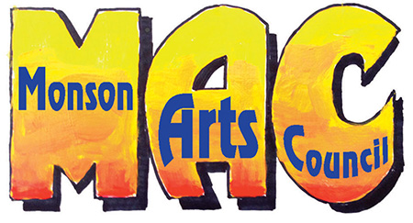Festival of Art ~ Sign up Here
P.O. Box 306 • Monson, MA 01057
www.monsonartscouncil.org • artshows@monsonartscouncil.org

Yes, we want to be part of the Regional Artists Festival in Monson on April 13, 2019

Organization__________________________________________________________________________________________

Address_______________________________________________________________________________________________

Town, State, Zip______________________________________________________________________________________

Nonprofit Organization ___________ No Charge

- Arts Business __________________ $35.00 (Make payment to : Monson Arts Council, and mail to MAC Festival of Art, c/o Tim Denney, 94 Lakeside Drive, Monson MA 01057. Or make an online payment via Credit Card or PayPal at MonsonArtsCouncil.org

Contact Person for Event_____________________________________________________________________________

Email for Contact Person_______________________________________ Telephone________________________________

If you have a preference for a location in Memorial Hall, a map is included below. Please indicate your preference here. __________________________. Booths will be assigned in order of registration dates.

Thank you for your early reply. Please reply no later than April 1.
Questions: Maureen Solomon – 413-267-3042.

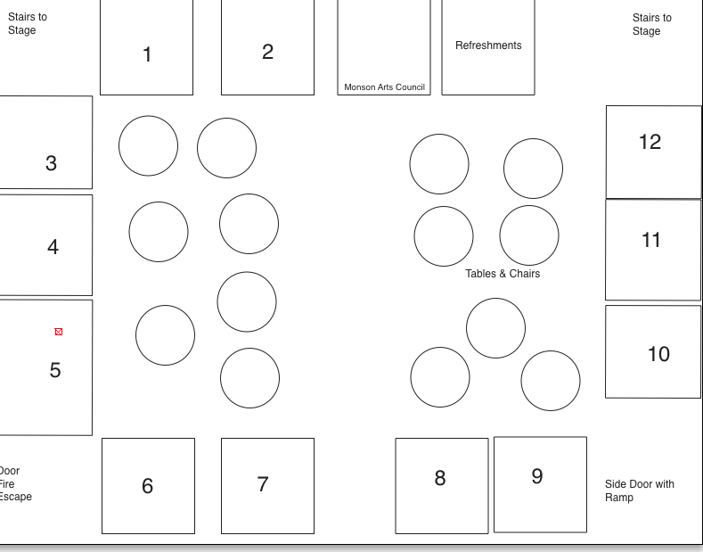

Already Assigned: Booth 5 -

Mail Entry Form: Festival of Art, c/o Tim Denney, 94 Lakeside Drive, Monson MA 01057

