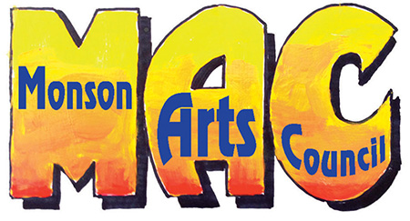
P.O. Box 307 • Monson, MA 01057 • www.monsonartscouncil.org • artshows@monsonartscouncil.org

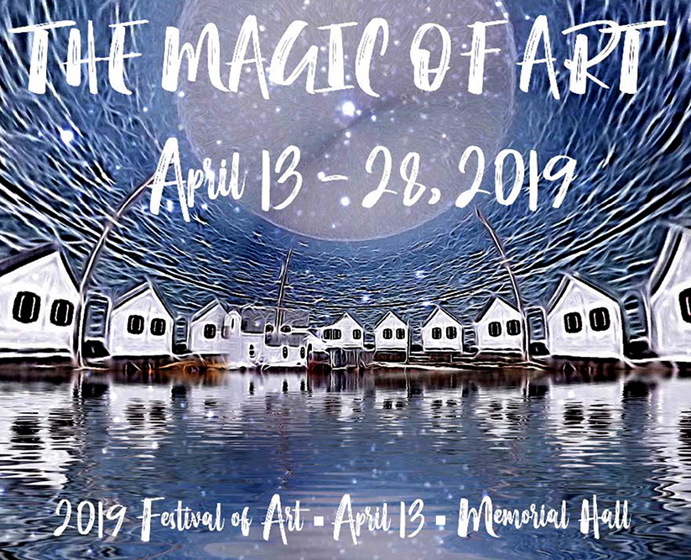
Full Moon at the Lake House, Media Altered photo © Carol Dunn

